Business Document Notes: Research Report
Business Document Notes: Research Report
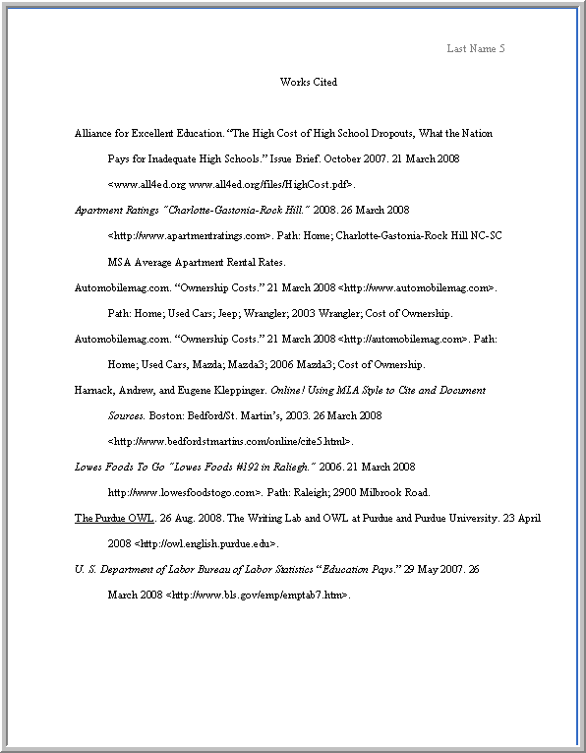
Description – What is it and Why is it used?
Margins
- All margins should be set to 1 inch
Components (in order)
Title page (optional)
Title
Header
Body
Parenthetical citations
Endnotes/ Footnotes
Works cited
Notes page

