APPLIED LEARNING CHALLENGE – LEARNING SYTLES

Directions:
1. Students will be divided into groups with different learning styles represented on each team as possible.
2. Once you are in your group, each person will discuss a topic in which they are considered an expert. After everyone has shared a topic they are good at doing, the group will decide what topic the group will teach the class. In your lesson, you should use at least 4 learning styles to teach the class about your topic.
- Verbal
- Logical
- Kinesthetic
- Visual
- Musical
- Interpersonal
- Intrapersonal
- Naturalistic
These should be simple topics that need little preparation to teach. Example topics include:
- Tying a shoelace b. Curling hair
- Making a paper airplane
- Playing Tic-Tac-Toe e. Washing your hands
- f. Drawing a unique smiley face
3. You will have time to identify your topic and plan your lesson. Think about the different ways each of them learns best and incorporate those styles into their teaching.
4. You will have maximum 20 minutes to teach you activity to the class.
APPLIED LEARNING CHALLENGE – LEARNING SYTLES
Directions: Identify your topic, list your learning styles and the activity in your lesson to support that learning style
TOPIC:

LEARNING STYLE | ACTIVITY

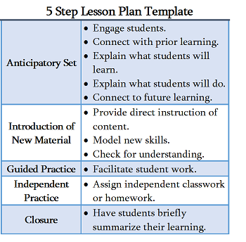

5 STEP LESSON PLAN
1 | Anticipatory Set
2 | Introduction of New Material
3 | Guided Practice
4 | Independent Practice
5 | Closure

