Name ______________________________ Date ________ Grade ___ Track ___
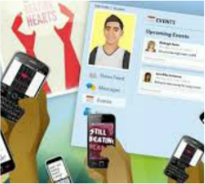
DIGITAL LITERACY & RESPONSIBILITY

Direction: Choose one module from the Digital Literacy platform and answer the following questions:
Module Name and Number: _____________________________________________________
 |  | Response
1 | What was this module about?
2 | Identify one concept that stand out to you? (What did you learn)
3 | How can you apply this to your school or home setting?
Direction: Log onto the class website www.cydunn.com Keyboarding & WP Digital Literacy Password 123hgms Click the Ignition Discussion Questions. Identify the module you selected and answer the questions for the module.
Discussion Questions
1
2
3

