Database Fundamentals

Directions: Record notes while viewing the Database Fundamentals Power Point

Definition:
Business Uses of Databases
Can you associate company names with the database examples?

Telephone book: Customer data:
Student Data: Real estate listings:
Music: Hospital/patient data:
Fingerprints: Inventory:
Dictionaries: :

Tables
Main Topic:

Organization of a Database
Four
Database Objects:

1.

2.

3.

4.
Queries, Forms, and Reports will be discussed in 5.02

Just list the names of the objects here; don’t worry about definitions yet.

Field – Definition and Example

Record – Definition and Example
Entry – Definition and Example

Tables: the Building Blocks of all Databases
Table Components

College Database Activity
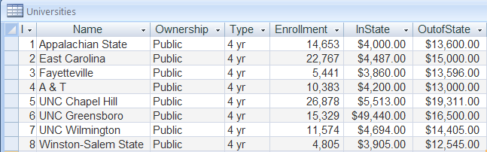

    - What are the field names?
    - What is the name of the table?
    - How many records are there?
    - How many entries are there?
    - Describe the contents of one record.
    - Describe the contents of one field.

A grouping or category of similar information contained in a table; a unique identifier for a category of information
The building blocks of all databases. They are used to group and organize the information within a database; arrangement of columns and rows. It is the fundamental building block of all databases.
Single piece of data in a database table.
A complete description of all of the fields related to one item in a table.
A tool used to organize, store, retrieve, and communicate groups of related information. Example: Card Catalog, online Library

Match the Word with the Vocabulary

Vocabulary:
Table
Database
Entry
Field
Record

