College Database Activity

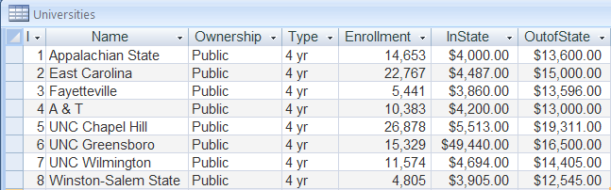

* + 1. What are the field names?
    2. What is the name of the table?
    3. How many records are there?
    4. How many entries are there?
    5. Describe the contents of one record.
    6. Describe the contents of one field.

C:\Documents and Settings\Administrator\Local Settings\Temporary Internet Files\Content.IE5\TMNG3IJS\MC900088594[1].wmf